*Florida International University*

*School of Computing and Information Sciences*

CIS 4911 - Senior Capstone Project

Software Engineering Focus

Feature Document

User Story #770

**Team Member:**

Jorge Nonell. Eric Aguiar, Alex Karpis, Chris Naranjo

**Product Owner(s)**:

Francisco Ortega

**Mentor(s)**:

Francisco Ortega

**Instructor**: Masoud Sadjadi

**User Story** **- Refactor UI in previous project code**

### Description:

* **As a developer I** **would like to** Refactor and redesign previous project code **so that I** can easier understand and add features in the future

### Acceptance Criteria:

1. redesign classes and header files
2. redesign structure
3. Group Device code into one namespace

**Use Case #770 – Refactor UI in previous project code**

Use Case:

Refactor UI in previous project code

Details:

Actor: Developer

Pre-conditions:

* Project working on VS2015
* Program Running

Description:

* Use case begins anytime a developer needs to interact with the UI code. This will affect the developers efficiency in working with the UI.
* The user story ends when the developer can interact with the UI in and easier and more efficient manner than before.

Post-conditions:

A developer can easier understand and add features to the UI

Decision Support:

Frequency: Often. Developers need to easily understand code

Criticality: High. Enables developers to work more efficiently

Risk:Low. Team members need to get used to new structure

Constraints:

Reliability: Very Reliable.

Performance: No performance improvements

Supportability:

Must work with ACER Multitouch

Modification History:

Owner: Eric Aguiar

Initiation date: 06/07/2016

Date last modified: 06/07/2016

**Use Case Diagram**

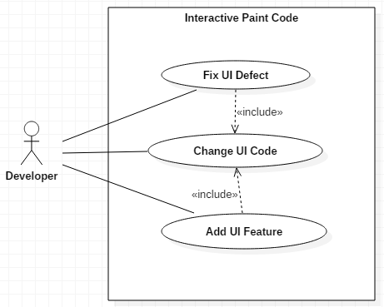

**Unit Test**

Sunny Day Tests

Test Case: Drawing Still Works

Test Purpose: Ensure that user can still draw on screen after UI is refactored..

Test Setup:

⦁ run program

Test Output:

Every line drawn correctly

Expected Output:

After pressing multitouch screen, the screen should activate drawing functions

**Integration Test**

UI can still activate different drawing functionalities and different device functions with any of the integrating devices, i.e. the RealSense, Leap Motion, and Eyex can still contribute to drawing